IE221 Probability - Teamwork 3

Experimental Verification of SLLN, CLT, and Monte Carlo Pi Estimation

Team Members
İbrahim Genç | 2211021036
Ayse Efsa Çelik | 2211021001
Fatmanur Doğan | 2311021001
Ecem Nur Yüksel | 2411013097

Date: 29 Dec 2025

Abstract. This report presents simulation-based evidence for three fundamental probability topics: the Strong Law of Large Numbers (SLLN), the Central Limit Theorem (CLT), and a Monte Carlo estimator of pi based on SLLN. Using i.i.d. samples from the uniform distribution U(0,1), we visualize convergence of sample averages, normality of standardized sums as n increases, and convergence of Monte Carlo pi estimates as the number of sampled points grows.

Introduction

The objective of Teamwork 3 is to experimentally verify (i) the Strong Law of Large Numbers, which guarantees almost sure convergence of the sample mean to the expected value, and (ii) the Central Limit Theorem, which explains why many aggregated quantities appear approximately normal. We also implement a practical application: estimating pi via Monte Carlo sampling in the unit square.

Simulation Setup

All experiments use independent and identically distributed random variables drawn from the uniform distribution on the interval. For this distribution, the theoretical mean is 0.5 and the variability is constant and known. A fixed random seed is used to ensure that the simulation results are reproducible. All figures are generated using Python and the matplotlib library and saved in the project repository.

Task 2 - SLLN Simulation

In this task, a large number of random observations are generated from the uniform distribution on . As the number of observations increases, the running (cumulative) average of the sampled values is calculated and tracked.

According to the Strong Law of Large Numbers, the sample average converges almost surely to the theoretical mean of
the distribution. Therefore, as more observations are included, the cumulative average is expected to fluctuate less and
stabilize around the true mean value of 0.5.

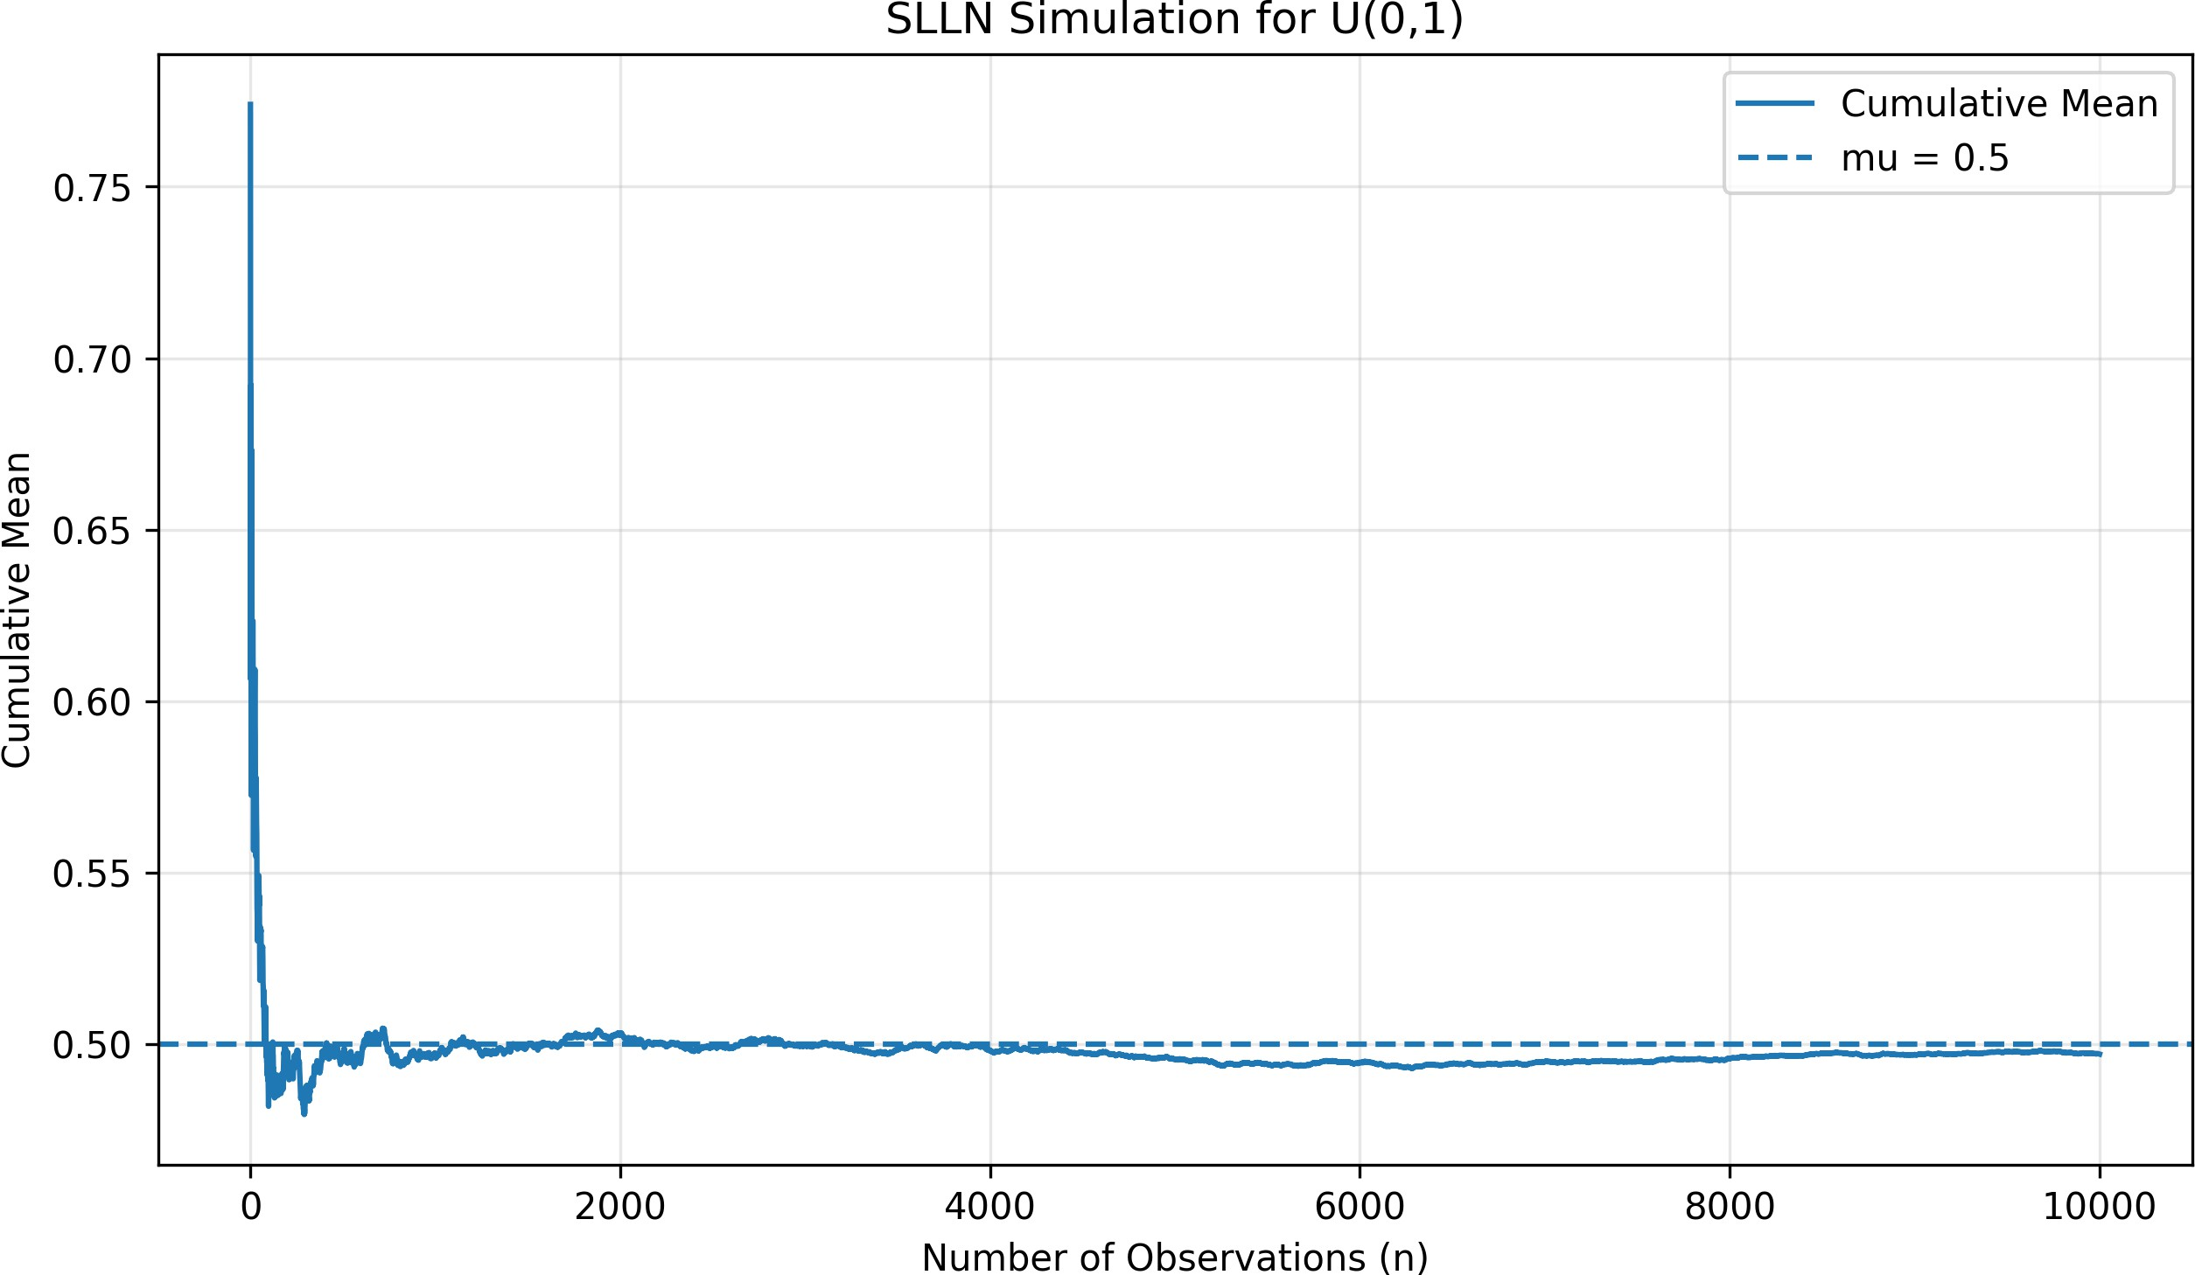
Figure 1. Cumulative mean (SLLN) for U(0,1) with n = 10,000. The dashed line is the theoretical mean mu = 0.5.

Task 3 - CLT Simulation

For each n in {2, 5, 10, 30, 50}, we run m = 1000 independent experiments. In each experiment we sum n U[0,1] variables to obtain $S_{n}$ and then standardize: Z = ($S_{n}$ - n* μ) / (σ*$\sqrt{n}$). CLT predicts that as n grows, the distribution of Z approaches N(0,1). We assess this using histogram with an overlaid standard normal density and Normal Q-Q plots.

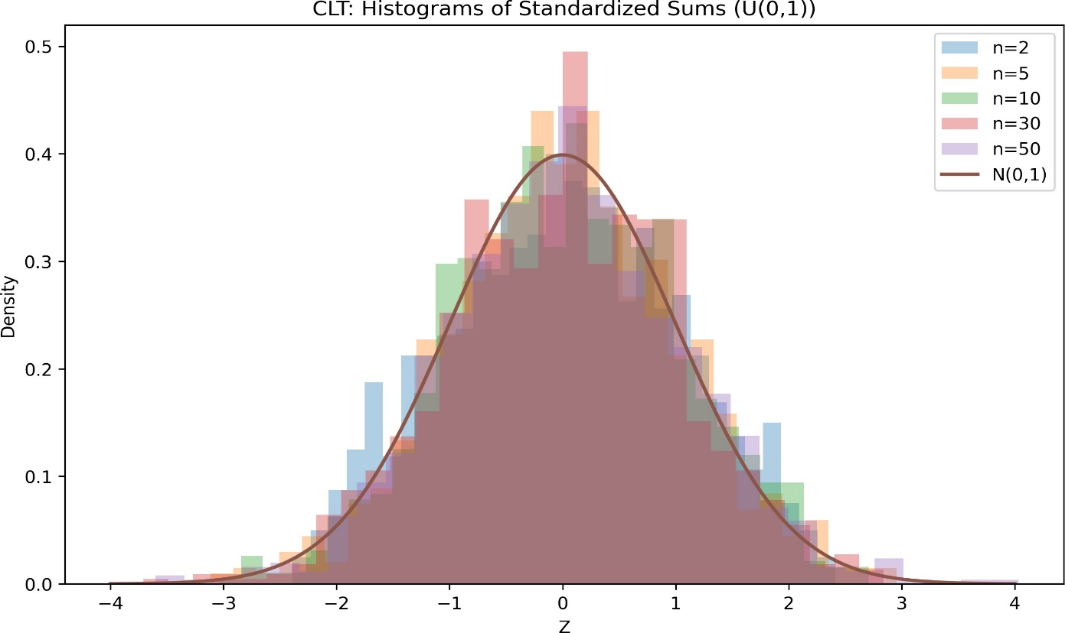

Figure 2. Histograms of standardized sums Z for different n values with the N(0,1) density overlaid. As n increases, the histograms more closely match the normal curve.

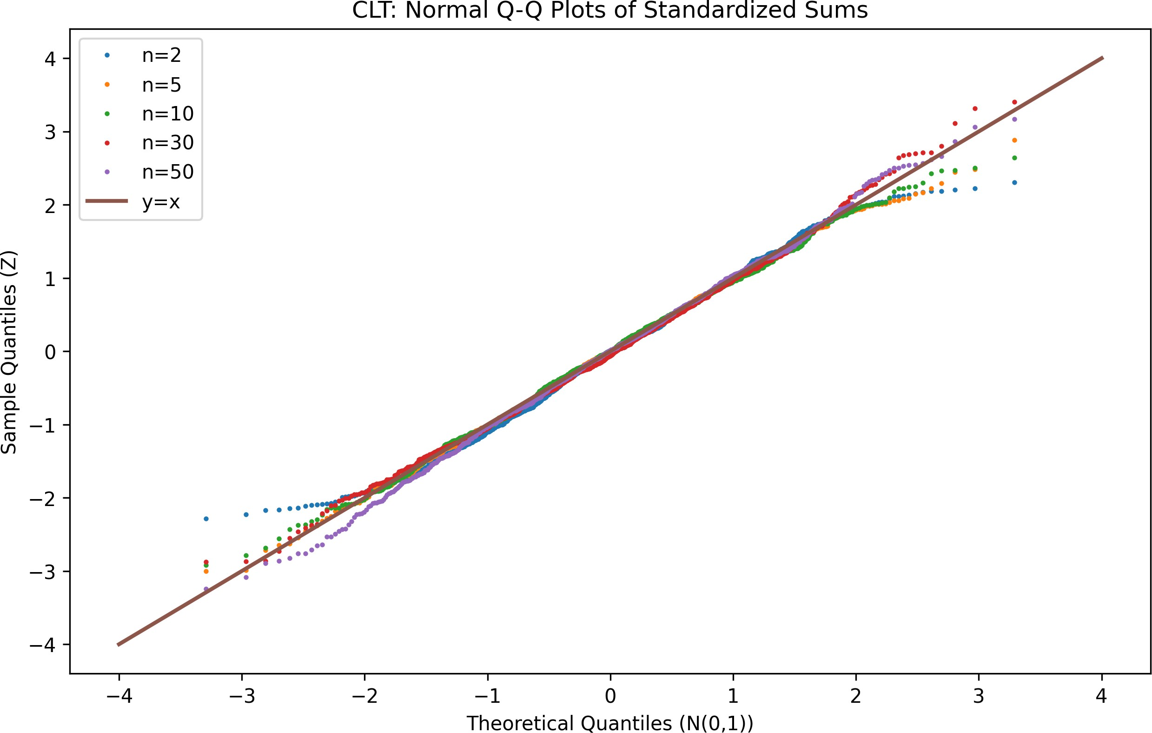

Figure 3. Normal Q-Q plots of Z for different n values. Points align more closely with the y = x line as n increases, indicating improved normality.

Task 4 - Monte Carlo Pi Estimation

We sample $n=10,000$points $\left\{(x_{i},y_{i})\}_{i=1}^{n}\right.$independently and uniformly from the unit square $\left[0,1]×[0,1\right]$. A point $\left(x_{i} , y_{i}\right)$is counted as being inside the quarter unit circle whenever $x_{i}^{2}+y_{i}^{2}≤1$. If we define the indicator $I_{i}=1\{x_{i}^{2}+y_{i}^{2}≤1\}$, then the proportion of sampled points that fall inside the quarter circle is ${\hat{p}}_{n}=\frac{1}{n}\sum_{i=1}^{n}{I_{i}}$. Since the area of the quarter unit circle equals $\frac{π}{4}$, we have $E[I_{i}]=P(x_{i}^{2}+y_{i}^{2}≤1)=\frac{π}{4}$. By the Strong Law of Large Numbers, ${\hat{p}}_{n}\overset{\text{a.s.}}{→}\frac{π}{4}$as $n→∞$. Therefore, the Monte Carlo estimator ${\hat{π}}_{n}=4{\hat{p}}_{n}=\frac{4}{n}\sum_{i=1}^{n}{I_{i}}=4⋅\frac{\#\{i: x_{i}^{2}+y_{i}^{2}≤1\}}{n}$converges almost surely to $π$as $n$increases. Finally, we plot ${\hat{π}}_{n}$versus $n$and include the true value $π$as a horizontal reference line for comparison.

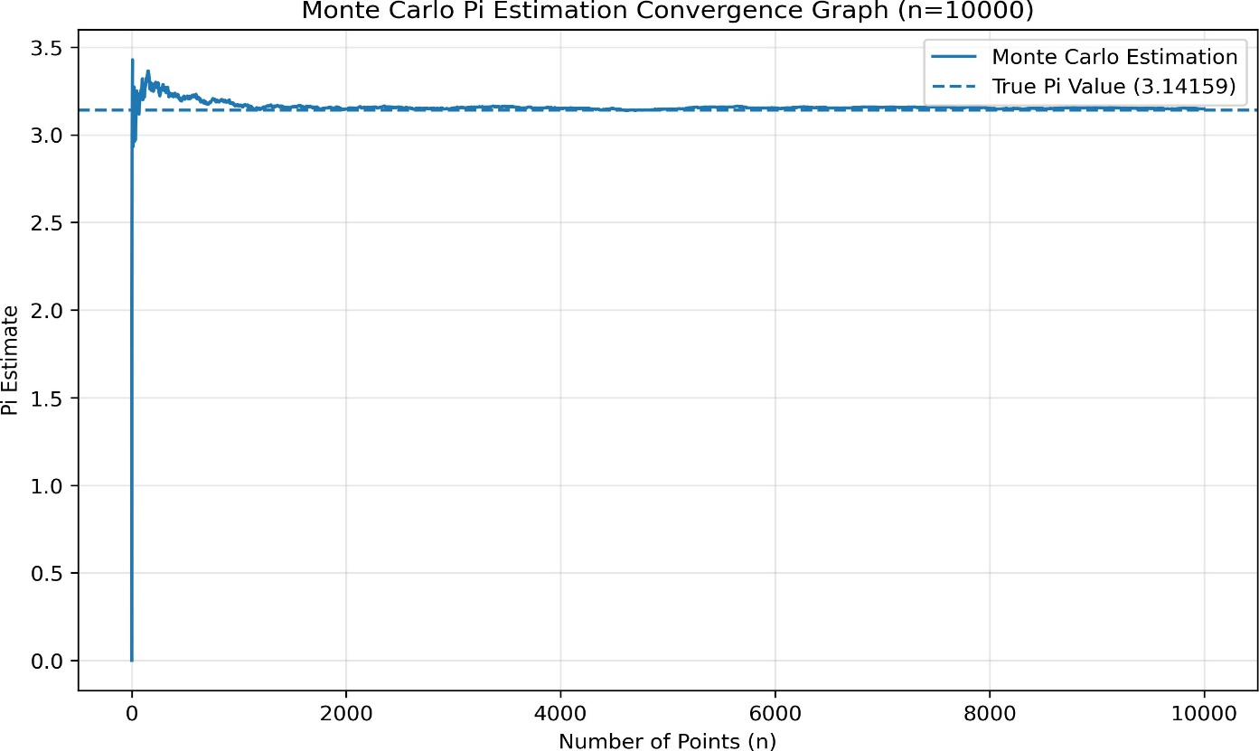

Figure 4. Monte Carlo estimate of pi versus number of sampled points (n = 10,000). The estimate stabilizes around the true value as n grows.

Discussion

The SLLN figure shows a typical sample path: the cumulative mean fluctuates substantially for small n and then settles near 0.5 as more observations are added. In the CLT experiment, small n values (e.g., 2 or 5) yield distributions that are noticeably non-normal, while for n = 30 and n = 50 the histograms closely track the N(0,1) curve and the Q-Q points lie near the reference line. Finally, the Monte Carlo pi curve demonstrates a concrete application of SLLN: the estimator is noisy at first but becomes more stable and accurate as n increases.
Overall, the simulations match the qualitative predictions of the theorems and illustrate how sample size affects convergence and approximation quality.

Conclusion

Through reproducible simulations in Python, we empirically verified key behaviors predicted by SLLN and CLT and demonstrated Monte Carlo estimation of pi as an application of SLLN. Larger sample sizes lead to more stable sample means, more normal-like standardized sums, and more accurate Monte Carlo estimates.

References
IE221 Probability (Fall 2025-2026) - Teamwork 3 handout and course materials.

